07 December 2015
The Permanent Secretary participated at the meeting EU State Secretaries and Secretaries General in Amsterdam in view of the Netherlands’s Presidency of the Council of the EU
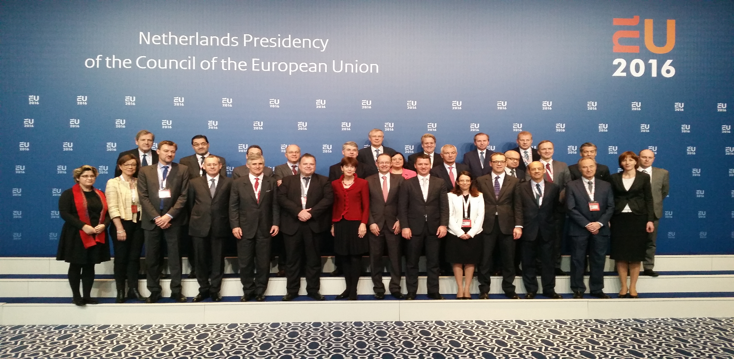

The Permanent Secretary of the Ministry of Foreign Affairs, Ambassador Alexandros N. Zenon, participated at the meeting of EU States Secretaries and Secretaries Generals in Amsterdam on November 30 and December 1, 2015. The meeting took place in view of the Netherlands’s Presidency of the Council of the EU in the first semester of 2016. The Minister of Foreign Affairs of the Netherlands Mr. Koenders presented the priorities of the EU Presidency. The four main priorities are: (1) Europe as innovator and job creator, (2) An integral approach to migration and international security, (3) Solid and future proof of European finances and a robust Eurozone, and (4) A climate and energy policy that is looking ahead. The participants also exchanged views on the review EU Global Strategy on Foreign and Security Policy and on the operation of the European External Action Service.

